**Genetic barriers to gene flow in hybrid swarms**

Silu Wang, Matt J. Nalley, Doris Bachtrog

University of California, Berkeley

3040 VLSB, Berkeley, CA, USA 94720

Corresponding author email: dbachtrog@berkeley.edu

**Introduction**

Speciation is the fundamental process that generates the diversity of life (Darwin 1859). The core genetic mechanism underlying speciation is genetic incompatibility (BDMI)(Bateson 1909; Dobzhansky 1941; Muller 1942), the combination of alleles at more than one locus that interact to reduce hybrid fitness. Current understanding of BDMIs is limited to a few loci (Fisher 1930; Wright 1931; Dobzhansky 1937), whereas the genome-wide organization of genetic incompatibility during speciation remains poorly understood (Campbell et al. 2018).

Tackling genomic organization of BDMI entails a wide variety of genetic combinations across genomes with fitness estimations. Hybrid swarms, the multi-generational laboratory hybrid population generated by interbreeding diverged lineages, are ideal to investigate genomic BDMIs. Hybrid swarms contain a variety of genomic combinations, allow time-series tracking of genomic dynamics, and reflect the mode of BDMI evolution when analyzed comparatively.

**-**selection again hybrids would be more evident in later generation hybrids

**-**Increase in LD among barrier loci over generations of hybrid swarm

Here we generated hybrid swarms of *Drosophila* a species pair with extensive genomic differences and sequenced the random samples from the hybrid swarm for 27 generations to identify genome-wide BDMIs.

We investigate how are ancestry blocks get broken down (by hybridization) and re-assembled (by selection). In particular, we look for candiate barrier genomic modules.

**Methods**

*Hybrid swarm*

N= of each sex of each species were crossed

Plexiglass (dimension), the arena is maintained at room temperature, humidity, light-dark cycle.

*Sequencing*

We sequenced at early generation (0-5, N=21), generation 10 (N=1), 21 (N=22), 27 (N=44), and 28 (N=37).

*Sequence processing*

We aligned the reads to a *sulfurigaster* reference with bwa (Li 2010). Trim the reads, read quality cutoff =

*Ancestry calling*

Ancestry HMM was used to infer local genomic ancestry among hybrids in the hybrid swarm experiment. Following setting was employed: *-a 2 0.5 0.5 -p 0 -3 0.5 -p 1 -3 0.5 -r 0.000005*. In particular, we assumed equal parental ancestry contributions, and recombination rate being 5X10-6, and estimated the generations before present in which the ancestry pulse occurred. Ancestry genotype was called if the posterior probability > 0.6.

We first find the fixed difference (SNP-based FST =1) between nasuta and albomicans. Then we prepared the input for ancestry HMM with a custom script. 0=nasuta, 0.5=heterozygotes, 1=albomicans.

*Clustering*

We performed imputation (missing ancestry genotype was replaced by window mean) with 2Mb sliding windows for each muller element before removing the individual with missing data for at least one site. Thereafter several individuals remained from early generation (N=36), generation 10 (N=1), 21 (N=15), 27 (N=31), and 28 (N=29). Because there were only 1 individual remaining for generation 10, we did not further analyze this generation.

Because the ancestry-informative SNPs are not independent to each other due to structural variation in the genomes, we used k-means-cluster algorithm to find independent units in the genome. With the input being the SNP-based ancestry genotype matrix for each individual across of generations, we iteratively increment the number of clusters starting from k=1 until 95% of the total variance is explained by between-cluster variance. Within each cluster, the mean ancestry index is used to represent the cluster ancestry. This procedure resulted in 43 clusters in Muller A, 89 in Muller B, 73 in Muller CD, 42 in Muller E, and 3 in Muller F (Figure 1).



**Figure 1** Ancestry genetic clusters (in columns) in hybrids of various generations (rows).

*Genomic clines*

To detect potential genetic clusters that serve as barriers to gene flow, the pattern of introgression for each genetic cluster was inferred with genomics clines (Gompert and Buerkle 2011). We estimated cline parameters for each genetic cluster based on cluster-specific introgression relative to the genomic background. We regarded the genetic clusters with weighted average (weight=1/(1+7+8) for generation 21, weight =7/(1+7+8) for generation 27, weight=8/(1+7+8) for generation 28) beta > 0.5 as the candidate barrier clusters. We weighed the later generation more, because the signatures of selection for genetic barriers tend to be more evident towards later generations that have been experiencing selection for longer.

*Structural variants* [Potentially add this later when Dat has the updated info]

*Signature of selection*

To further investigate if there is selection elevating LD among the barrier clusters than the genetic clusters in the rest of the genome (control clusters), we compared pair-wise LD among barrier clusters and the rest of the genome within generation 21, 27, and 28. In addition, we tracked the LD difference between barrier loci and the rest of the genome over generations. If there is selection on these barriers, LD should increase (relative to the rest of the genome) towards the later generations.

Specifically, we calculated pair-wise r2 among the barrier clusters versus control clusters. We adopted bootstrapping test with 100,000 iterations. Briefly, for each generation, a pair of barrier clusters were randomly drawn among all the barrier clusters and control clusters, the difference of r2 between the barrier and control clusters were calculated. The 95% CI of the barrier-control cluster r2 should be greater than 0 for each generation. The bootstrap distribution of barrier-control cluster r2 were then compared among generation 21, 27, and 28. If there is selection for elevated barriers, expect the barrier cluster r2 to increase over generations.

*Simulation*

To explore the neutral segregation of ancestry blocks in 28 generations the hybrid swarm, we simulated admixture of the hybrid swarm with a custom script adopted from the existing R code (Gompert and Buerkle 2016).

**Results**

There are 61 genetic clusters (24 in Muller B, 28 in Muller DC, 9 in Muller E) identified as candidate barrier clusters (Figure 2).

LD is significantly higher among the candidate barrier clusters than the control clusters in generate 21 (95% CI of difference: 0.170-0.175), 27 (95% CI of difference: 0.257-0.262), 28 (95% CI of difference: 0.241-0.247) (Figure 3 A). There was a significant elevation in barrier clusters LD in generation 21to 27 (95% CI of r2 change in barrier clusters: 0.041-0.042), generation 21 to 28 (95% CI of r2 change in barrier clusters: 0.040-0.041), but no significant change was observed between generation 27 and 28 (95% CI of r2 change in barrier clusters: -0.0007-0.0001) (Figure 3 B).



**Figure 2** Genome-wide estimation of beta parameter of genomic clines.



**Figure 3** **LDs among barrier genetic clusters reveal signature of selection**. **A**, there is significantly greater LDamong barrier clusters than control clusters in generation 21, 27, and 28. The 95% CI of bootstrap distribution of the r2 difference among barrier clusters versus control clusters are greater than 0 (95% CI = 0.170-0.175 for generation 21 colored in light green, 95% CI = 0.257-0.262 for generation 27 colored in mid green, 95% CI = 0.241-0.247 for generation 28 colored in dark green). **B**, the LD among barrier clusters significantly increased over generations. The Δr2 is significantly greater than 0 between generation 21 and 27 (red, 95% CI = 0.041 to 0.042), as well as between generation 21 and 28 (blue, 95% CI = 0.040 to 0.041), but not between generation 27 and 28 (yellow, 95% CI = -0.0007 to 0.0001).



**Figure 4** LD network among candidate barrier clusters in different generations. Each node represent a barrier cluster in different Muller elements (turquoise: muller B; yellow: Muller CD, blue: Muller E). The width and color (gradient black to olive green) of the edges is proportional to LD (minimum = 0.5).

**Discussion**

With generations of hybrid swarms, we have identified signatures of barriers to gene flow and the elevated LD among the barriers over generations of admixture which is expected to break down ancestry blocks under neutral scenario. The greater LD among barrier genetic cluster relative to the rest of the genome suggests selection keeping the barriers together. In addition, the

elevation of the LD among barrier clusters over generations of admixture further revealed the role of selection.

**Reference**

Bateson, W. 1909. Heredity and variantion in modern lights. Pp. 85–101 *in* Darwin and Modern Science. Cambridge University Press, Cambridge.

Campbell, C. R., J. W. Poelstra, and A. D. Yoder. 2018. What is Speciation Genomics? The roles of ecology, gene flow, and genomic architecture in the formation of species. Biol. J. Linn. Soc. 124:561–583.

Darwin, C. 1859. On the Origin of the Species.

Dobzhansky, T. 1941. Author Genetics and the origin of species.

Dobzhansky, T. 1937. Genetics and the Origin of Species. Columbia University Press, Columbia.

Fisher, R. A. 1930. The genetical theory of natural selection. Oxford Univ. Press, New York, NY.

Gompert, Z., and C. A. Buerkle. 2011. Bayesian estimation of genomic clines. Mol. Ecol. 20:2111–2127.

Gompert, Z., and C. A. Buerkle. 2016. What, if anything, are hybrids: enduring truths and challenges associated with population structure and gene flow. Evol. Appl. 9.

Li, H. 2010. Aligning new-sequencing reads by BWA BWA : Burrows-Wheeler Aligner. Slides, doi: 10.1002/pssa.200673542.

Muller, H. J. 1942. Isolating mechanisms, evolution and temperature.

Wright, S. 1931. Evolution in Mendelian Populations. Genetics 16:97–159.

**Supplementary**

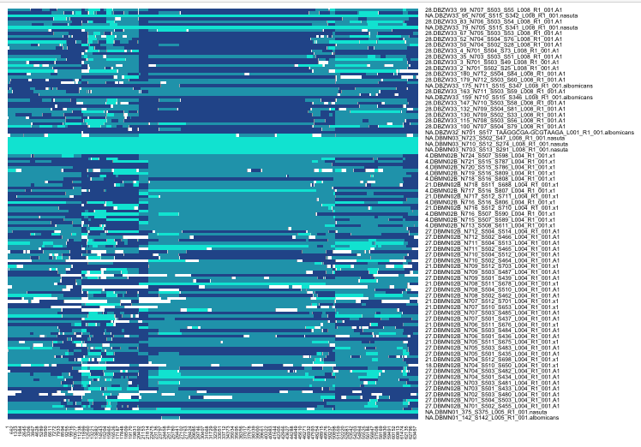

**Figure S1** ancestry haplotypes, each column is a SNP, each row is an individual.

**Table S1**

|  |  |  |  |  |  |
| --- | --- | --- | --- | --- | --- |
|  | **Muller A** | **Muller B** | **Muller CD** | **Muller E** | **Muller F** |
| Ancestry-informative sites | 8928 | 12922 | 29142 | 11508 | 1532 |
| K-means clusters | 43 | 89 | 73 | 42 | 3 |